**1. INTRODUCTION**

Welcome to use our BUPT cinema kiosk. Here is the user manual for you to use the system.

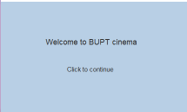

Now people are watching movies in the cinema more and more frequently, but the way to purchasing ticket can be kind of cumbersome.

Our system is designed to help customers to self-purchase tickets with efficiency and effectiveness.

1.1 BACKGROUND

**2. THE METHOD OF USING THE SYSTEM**

1. First, after installing, compiling and running the Main.java and Clock.java with the guide of Readme.txt ,we can see this window on the screen.

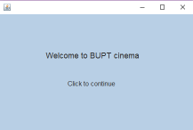

1. Click somewhere on the screen you like. Then you can see this screen. You can click “Buy it now” after the film you like. For example we click the button after the first movie.

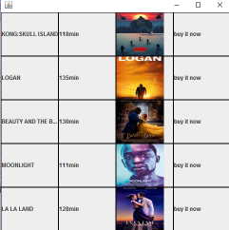

1. You can click time which is in black(available) to choose your favorite time as well as screen. If you click “return”, you can go back the “Screen 2” to choose the film again.

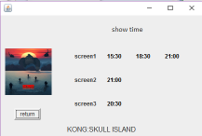

1. You can click seats you liked, one or more seats are possible, then click the “Buy”. Blue are available seats and grey are sold seats. After this you will go to the next screen(6) to choose your ticket type. If you want to change the time/screen of the film you have chosen, you can click “return” to go back screen3.

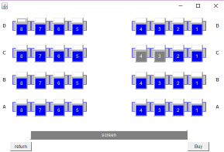

1. As we can see, if you choose the seats, the seats will change to red.

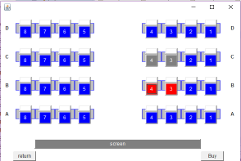

1. If you click “Buy”, you will see this screen. On this screen, you can choose the type of tickets you want to buy. Click the “Buy” to go to purchase screen(7).

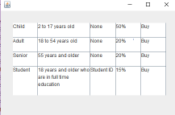

1. After clicking, you can see this screen to let you confirm your ticket details, total cost, and prompt you to pay your money. Click confirm to pay(8), click return to choose file screen(2).

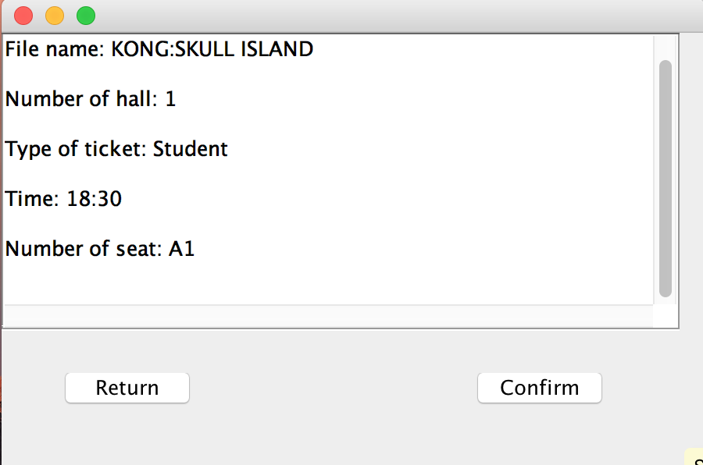

1. If the purchase is successful, the kiosk will print the ticket(s) you bought and you can take the ticket to see the movie.

After few second, the screen will automatically go to the welcome screen waiting for another customer to purchase.

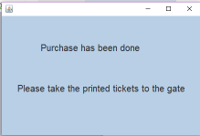

9. At every day 24:00, if the Clock.java is running, a report will automatically be sent to the administrator. File name is the date.txt, for example 20170529.txt.

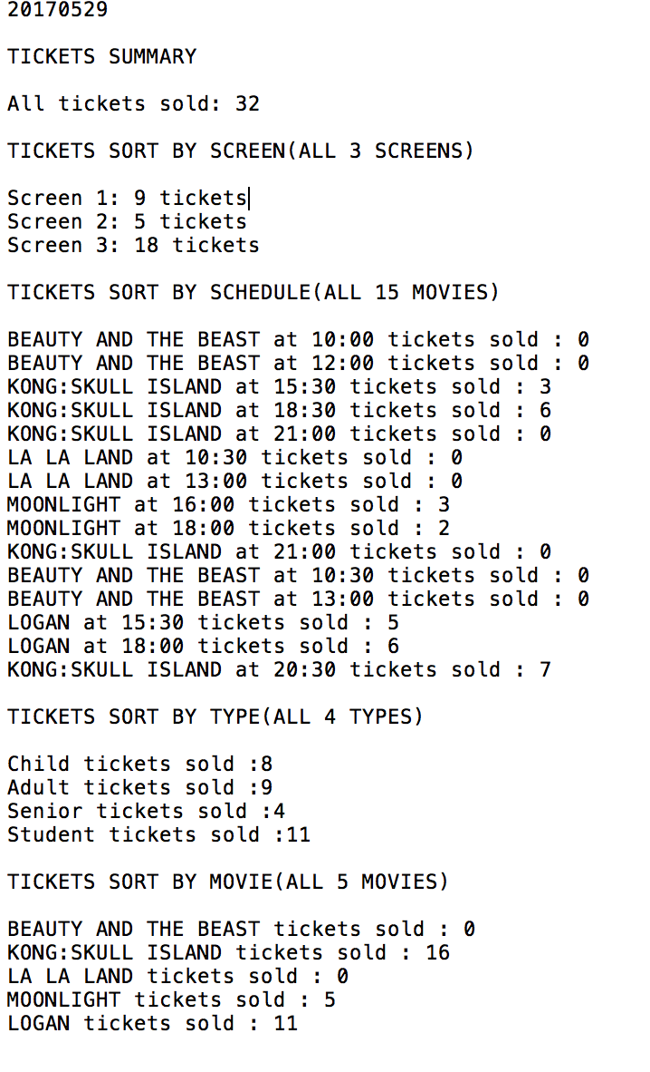

After each program will automatically delete all the content in the screen files, in this case screen1.txt, screen2.txt, screen 3.txt. Administrators can modify the movieInfo.txt as well as schedule files (schedule1.txt, schedule2.txt, schedule3.txt) as they what following the format in each file before the everyday running of program (Main.java).